TIMOTHY'S STORY

EARLY YEARS
At 26 months, Timothy was referred to child services for evaluation because he was "out of control." His parents, Alice and Steve, referred to him as a "holy terror." According to the parents, when Timothy was told "no," he threw himself on the floor kicking and screaming and he would hit and kick any adults when they approached. When Timothy became very upset he would bang his head on the floor and bite himself
. 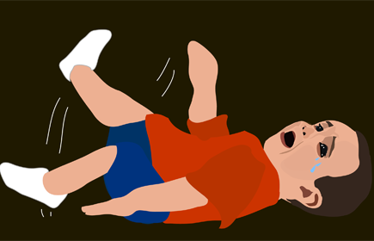

HOME LIFE
History reveals considerable violence at home between Alice and Steve which Timothy often witnesses. Steve frequently found himself in between jobs. His mother worked long, overnight shifts for a minimum wage salary. Both parents regularly used spanking as method of discipline.
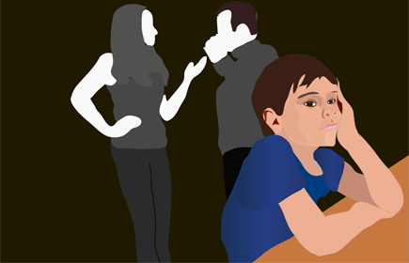

DAYCARE
Timothy spent 10 hours per day at an illegal daycare home where one caregiver was responsible for 12 children all under the age of four. The caregiver used spanking to discipline Timothy and the other children in her care. Timothy's mother often picked in a soiled pamper and with a pacifier in his mouth. The parents had some concerns about the Timothy's childcare—including unsanitary conditions, and snacks consisting of potato chips and cookies; they did not believe they had any choice however. The high-quality care centers in their area are too expensive.
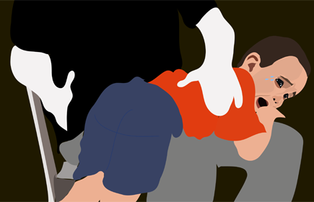

ELEMENTARY YEARS
At age six, Timothy was enrolled in a first-grade public school program. He never attended any formal preschool or kindergarten program. Timothy's teacher reported that he had difficulty making friends and was often seen playing on his own during recess. He rarely came to school prepared with the needed supplies or with his homework completed. Timothy occasionally had an angry, frustrated reaction to his teacher and often ignored the classroom rules.
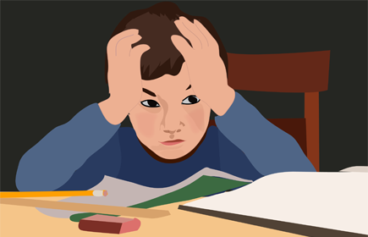

ADOLESCENCE
At age 11, Timothy was held back from being promoted to sixth grade. His academics were far below what would be expected for a fifth-grade student and he struggled with both reading and writing. Timothy had few friends and was suspended briefly for hitting another student over a minor disagreement.
